Student Name: __________________
Class and Section __________________
Total Points (20 pts) __________________
Due: Feb 14, 2011 before the class

Project: Accessing and updating a Staff table (JSP)

CSCI 5520 Rapid Java Application Development
Armstrong Atlantic State University

Problem Description:

Write a JSP that views, inserts, and updates staff information stored in a database, as shown in the following figure. The view button displays a record with a specified ID. The Staff table is created as follows:
create table Staff (
id char(9) not null,
lastName varchar(15),
firstName varchar(15),
mi char(1),
address varchar(20),
city varchar(20),
state char(2),
telephone char(10),
email varchar(40),
primary key (id)
);

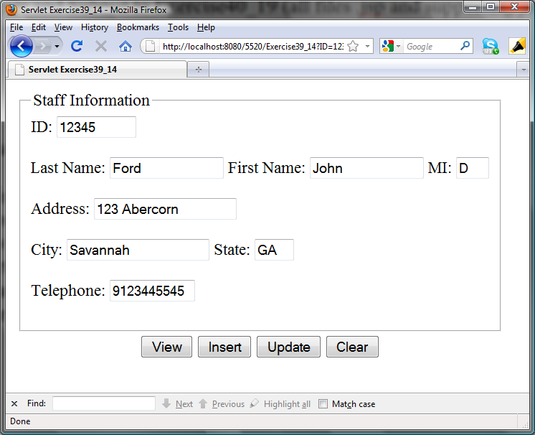

Source code:

Screen shot:

What to submit?

- This document.
- Save/Compile and Submit to Exercise38_19 (all files .jsp and supporting java files) on LiveLab.

2. Fill in self-evaluation:

- Can you display the form using HTML? _________
- Can you connect to the database? ______
- Is the View button implemented correctly? _______________
- Is the Insert button implemented correctly? ________
- Is the Update button implemented correctly? ________
- Is the Clear button implemented correctly? ________

